2. Python program to print the pattern

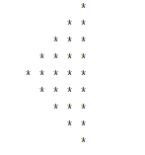

def pattern(n):

    k = 2 * n - 2

    for i in range(0, n-1):

        for j in range(0, k):

            print(end=" ")

        k = k - 2

        for j in range(0, i + 1):

            print("* ", end="")

        print("")

    k = -1

    for i in range(n-1,-1,-1):

        for j in range(k,-1,-1):

            print(end=" ")

        k = k + 2

        for j in range(0, i + 1):

            print("* ", end="")

        print("")

pattern(5)

**output:**

